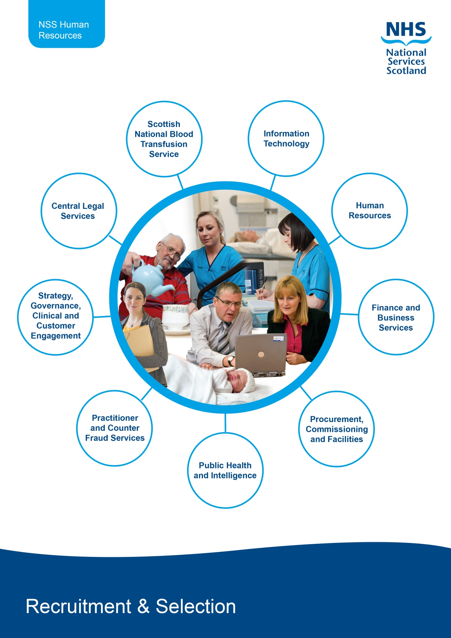

Managers Guide to the recruitment process

w
Manager completes the ‘Add a Job’ section on Job Train for vacancy approval

Candidate commences employment
END OF PROCESS
Pre-employment checks completed satisfactory, the Recruitment Team write to candidate to confirm unconditional offer.
The Recruitment Team advise all candidates and commence pre-employment checks for successful candidate(s)
Advert agreed and post advertised
Post deemed suitable for redeployment and redeployment process is followed
END OF PROCESS
Post deemed unsuitable for redeployment and recruitment process commences

Advert Closes and Recruiting Manager completes shortlisting in JobTrain

Recruiting Manager updates Jobtrain with interview dates interviews

Interview takes place and Recruiting Manager updates Jobtrain interview outcomes for each candidate, uploads the interview paperwork and completed the offer form in JobTrain

Advert, Job Description & Person Specification

Before you complete the Add a Job section on Job Train you should have a job description and person specification. The job description must be precise and unambiguous, specifying principal roles and responsibilities of the post-holder and must follow the standard format. The job description used should have been through the job evaluation process and will have a CAJE reference number assigned to it. Please contact the HR Employee Relations and Reward team via Contact Us if you do not have the CAJE reference number.

The Person Specification describes the requirements of the ideal person to fill the post and is a profile of the necessary qualifications, personal skills and aptitudes.
The requirements of the Person Specification must be objective, measurable and free from any discriminatory bias. Criteria or requirements which are unnecessary to the post and which might exclude applicants or particular groups must not be included.

The Person Specification should indicate how the requirements will be tested through the recruitment process, e.g. from information on the application form, through the interview or through other selection processes.

Key Point to Remember:

Person Specification should not have any discriminatory bias e.g. no reference to age, sex, etc

A driving licence can only be a criteria in the person specification for driving roles

Writing the Advert

You should consider carefully whether other external advertising is necessary. It is your responsibility to draft the wording to the advertisement, ensuring that this reflects the requirements specified within the Job Description/Person Specification.
The content of the advertisement is essential to successful recruitment; the aim is to target the most suitable pool of applicants.

You can find templates of these documents via the link below;

https://www.nssscotland-hr.scot.nhs.uk/recruitment-services/recruitment-process/63927

Key Point to Remember:
Advert should be succinct and should clearly outline key aspects of the person specification, ensuring the appropriate template is used with the standardised NSS introduction.

Add a Job

For all recruitment activities (including Agency and Temporary Workers), you will need to create a vacancy via the Add a Job function on Job Train, which is available via the link below. First time users must log a call via Contact Us to be set up on the system as a Hiring Manager.

https://apply.jobs.scot.nhs.uk/client/

Budget holders, Finance contacts, Directors and Head of SBU’s will receive an automated email asking them to approve any vacancy that has been assigned to them.
A helpful user guide for the Add a Job function can be found via the link below.

https://www.eess.nhs.scot/hmss/jthm003/

Key Point to Remember:
Remuneration committee approval is required for new and additional posts at band 8d or above, Executive level D and above and Consultant vacancies. If applicable, please complete the RemCom approval form which is available on HR Connect. This must be attached to your vacancy in order for it to be approved.

Advertising

The Recruitment Team will advertise your vacancy internally using JobTrain and if applicable it will also be posted to the external JobTrain site and on the SHOW website. Adverts go live on a Tuesday and Friday for a 2 week period. However this can be extended should you require. We can also advertise on other external websites such as S1 jobs or total jobs. Please contact a member of the Recruitment Team should you wish to discuss this type of advertising.

Short listing

The Recruiting Manager can log into JobTrain and short list whilst the post is still at advert. Short listing should conclude when the post closes. The short listing panel should use the Job Description and Person Specification as the criteria to measure the applicant against. You should then complete the short listing assessment form for each candidate within JobTrain and input the interview details in the calendar event in JobTrain. You will also find a good example of a short listing form on HR Connect. Please note that the Recruitment Team will be unable to confirm interviews until shortlisting has been completed for each candidate.

When completing the short-listing, the panel must give explicit reasons as to why an individual is or is not shortlisted, by detailing which parts of the Person Specification the applicant does or does not meet. All applicants are able to submit a subject access request and are entitled to view the completed short listing forms.

Any candidate who has indicated that they wish to be part of the Job Interview Guarantee (JIG) scheme, and has met the minimum shortlisting criteria, must be offered an interview.

All short listing should be completed within 5 working days of the post closing.

Key Point to Remember:
A comprehensive shortlisting form should be submitted for all candidates. This should provide a robust explanation against each criteria within the person specification as to whether the candidate met the criteria or not.

Interviews

It is essential that at least one panel member has attended Recruitment Ready training. The documentation you require for interviews is attached to your vacancy within JobTrain under the “Job Approvals” tab vacancy and HR Connect.

The recruiting manager should meet with all Panel Members prior to the interview to ensure that questions are prepared and that all parties are familiar and comfortable with their responsibilities.

A well prepared interview is designed to obtain evidence of the candidate(s) skills, knowledge and experience; and to ensure that all candidates are given the same opportunity to present information and to ask questions about the job.

The interview questions asked should not be discriminative.

The aim is to gather sufficient information using probing questions where necessary, to gain a complete picture of the individual qualities and skills to enable a successful candidate to be appointed.

The Recruitment team will let you know in advance if candidates require any adjustments to attend their interview, please arrange for these adjustments to be put into place. Every effort will be made to accommodate the needs of a person with a disability when they arrive for their interview.

The Recruiting Manager should make arrangements for the interview including; arranging a suitable room, making available presentation equipment (where required) and welcoming the candidate on the day. Applicants are asked to bring a number of documents to interview. These documents act as proof of eligibility to work and live in the UK. You can find further information on what documents are accessible by referring to the “Verification of Identity and Right to Work in the UK Guide” guide available on HR Connect. Applicants are also asked to bring proof of qualifications and professional registration (where appropriate).

Following the interviews you should upload the interview paperwork for each candidate. This includes;
- Interview assessment forms
- Identification verification form and photocopies of candidate ID
- Variation approval form (VAF) if applicable

Please note that the Recruitment Team cannot process an offer of employment until all the documentation is returned.

Conditional Offer

The recruiting manager should verbally offer the post to the successful candidate. The Recruitment Team will confirm this in a conditional offer.

Any offer of employment will be subject to pre-employment checks. An offer of employment should generally be made at the bottom of the relevant pay banding for the post. Appointments at an alternative point of scale should only be made in conjunction with the organisation's policy on starting salaries to reflect relevant skills and experience.

When appointing a candidate who is new to NHS Scotland, please follow the guidance below if you are choosing to appoint above the bottom of the salary scale;

- Giving incremental credit without good reason is contrary to the principle of fair pay within Agenda for Change. In general, new starters to the NHS should start on the minimum of the scale and work their way up.
- Managers may offer new entrants a salary above the minimum of the scale to recognise relevant experience. The reasons and supporting evidence should be fully documented. Evidence may, for instance, be taken from the application form, references and job descriptions and staff transfer certificates. Verbal evidence provided at interview must be documented.
- A manager must be able to justify his/her decision, including the impact on:
- Others already in post (bearing in mind equality issues)
- Others outside the immediate department
- Consistency locally.
- Any decision likely to have an impact across a profession may only be taken by the professional head.
- In fairness to existing staff or staff who may be internally promoted, care must be taken that incremental points in recognition of experience only recognise completed years of experience at the level of the pay band in question, and not below it. If necessary, advice should be sought from the Recruitment Team. In the interests of equity, incremental credit will not be given for reasons other than complete years of experience. For instance, it will not be given due to market forces. If there are difficulties in recruiting staff, the recruiting manager may apply for a Recruitment and Retention Premium.
The recruiting manager should complete a Variation Approval Form (VAF) if they wish to appoint above the bottom of the salary scale for external candidates. Please note the VAF should be fully authorised prior to sending to the Recruitment Team.

Pre-employment checks

Pre-employment checks are carried out to ensure that the organisation is compliant with The Partnership Information Network (PIN) policies.

The checks that are carried out are –

Verification of Identity and Right to Work Checks – In accordance with PIN guidelines and Home Office regulations we are required to check the identity and right to work in the UK for all prospective employees. A list of accepted documentation is held within your e:ESS vacancy.

Occupational Health Checks – In accordance with PIN Pre placement health clearance enables NHS Boards to ensure that individuals are physically and psychologically capable of performing the tasks that will be required of them without risk to themselves or others.

Reference Checks – In accordance with PIN policy reference must be sought for all posts. If the successful candidate is internal to NSS we only need to take a reference from their current line manager. If they are external to NSS we need to take up reference that covers a minimum of 3 years of employment history.

Criminal Reference Checks – If a post requires regulated work the successful candidate will need to undergo a Protection of Vulnerable Groups Act (PVG) check. For some posts there is a requirement to obtain a Disclosure Scotland check. If you are unsure if these will be required please ask the Recruitment Team.

Professional Registration - Professional registration is intended to protect the public, making sure that those who practice a health profession are doing so safely. For all posts for which registration with a specific statutory regulatory body is a requirement, evidence of professional registration must be verified prior to placement. In the case of medical staff, evidence must also be sought that individuals hold a licence to practice.

Evidence of registration must be obtained by directly contacting the statutory regulatory body to ensure ongoing registration. Boards must ask the relevant body to specify whether:

- The individual is appropriately registered
- The registration covers the proposed role
- The registration is subject to any current restrictions
- The individual is the subject of any fitness to practice investigations which the regulatory body has a duty to disclose

Qualification Checks - For all posts for which a specific qualification is a requirement, evidence of the necessary qualifications should be verified. Even if relevant statutory regulatory bodies check qualifications as part the registration process, Boards must still separately verify an individual’s qualifications.

Unconditional Offer

Following satisfactory pre-employment checks the recruiting manager will be asked to confirm a start date. The recruiting manager will receive an email from the Recruitment Team to ask that the HR IT form is completed.

For external new starts the recruiting manager will receive a link to the online form handling portal for the completion of the HR IT eform. For internal transfers a link for the internal HR IT form will be emailed.

When the Recruitment Team receive the completed HR IT form, the contract of employment and unconditional offer letter will be sent to the successful candidate.

Please note that HR and IT need a minimum of 10 working days to add a new start onto e:ESS which then allows CSD to generate a user name and password. Please also be aware of payroll cut off dates when considering the start date for your candidate.

Key Point to Remember:
Please remember that you cannot start your new employee until the Recruitment Team confirms pre- employment checks are complete.

Appendix A
 | HR Responsibility | Your Responsibility
Recruitment Authorisation and Advert | Once your vacancy has been approved and received by HR, you will be assigned a Lead Recruiter who will be in touch regarding advertising dates and will be available to provide any support you require | To have all relevant documentation attached to vacancy and ensure all required fields are completed to avoid any delays
Short listing | The Recruitment Team will ensure that the shortlisting assessment form has been completed for each candidate prior to progressing to the next stage | Short listing each candidate providing a robust evidence for their decision to/not to shortlist.
 |  | Update JobTrain with details of interview (including date, times, panel and location). N.B. the Recruitment Team must be given a minimum of 7 working days notice of interview.
 |  | Arrange an appropriate interview room and any requirements such as projector, laptop etc.
Interview | Contact successful candidate at arrange interviews, providing a minimum of 5 working days notice. | Completing all relevant interview paperwork for each candidate and upload in JobTrain.
 | Contact unsuccessful applications and ensure records are updated. | Taking copies of and checking candidate ID.
 | Ensure all relevant interview paperwork has been sent to recruiting manager. | Completing the Offer form in JobTrain for the successful candidates(s) following interview.
Pre-Employment checks | Call successful candidate to go through the conditional offer process and confirm references. | Approving all pre-employment checks within 48 hours of receipt from the Recruitment Team.
 | Issue conditional offer to successful candidate(s), along with OH questionnaire and Disclosure/PVG if required within 72 hours of fully completed interview paperwork being received. | Confirm start date and starting salary, completing the VAF if required.
 | Chase outstanding pre-employment checks until all check received.
 | Update Manager with fortnightly progress and send to recruiting manager pre-checks for approval.
Offer | Issue unconditional offer within 48 hours of approval from recruiting manager. | Ensure IT forms are completed and returned – IT requires 8 working days to ensure their process is complete on time for the candidates start date.
 | Issue contract of employment prior to commencement of employment

